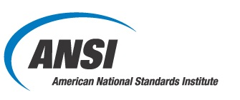

America Makes & ANSI Additive Manufacturing Standardization Collaborative (AMSC)
Phase 2 Working Group (WG) Sign-Up Sheet (updated 9/25/17)

Please sign me up for the WGs below  (check all that apply) | Please indicate your sector below  (chose the one that most aligns with your interest)
Working Groups | Industry-Sector
Design WG ____ | Aerospace/Defense ___
Precursor Materials WG ___ | Medical ___
Process Control WG ___ | Ground Vehicle/Heavy Equipment ___
Post-processing WG ___ | Energy ___
Finished Material Properties WG __ | Industrial & Commercial Machinery ___
Qualification & Certification WG ___ | Electronics ___
Nondestructive Evaluation WG ___
Maintenance WG ___
Polymers WG ___ (if you sign up for this WG, you do not need to sign up for the WGs above unless you also have an interest in metals AM standardization)
Medical WG ___ (if you sign up for this WG, you do not need to sign up for any of the WGs above)

Please provide your contact details below.
Name:
Title:
Organization:
Address:
Phone:
Email:
Web address:

Please email the completed sign-up sheet and your contact details to amsc@ansi.org

