PWG Meeting
October 18-20, 2010
Lexmark International Inc is hosting the October PWG Meetings on October 18 - 20, 2010 in Lexington, Ky. These meetings will be held at Lexmark's campus in Lexington, KY - see below for location details. Wireless Internet connectivity will be available for these meetings. A light breakfast and afternoon snacks will be served, but participants will be responsible for their own lunch and dinner arrangements.
Meeting Location Details
The PWG meeting will be held at Lexmark International in Lexington, KY on October 18-20, 2010 in building 082, shown below:
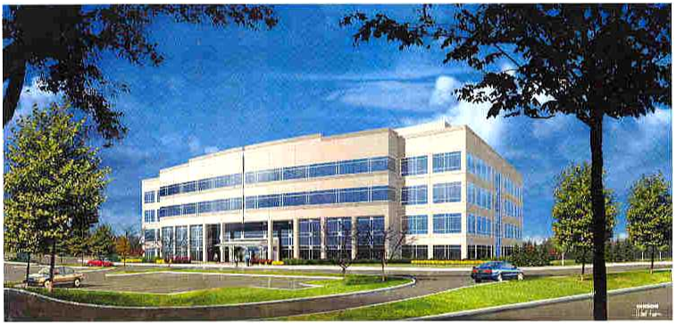
Address:

Building 082,
Lexmark International Inc, 740 New Circle Road, Lexington,. KY 40550
Closest Airport: Lexington (LEX)
Map and Directions: See below
Contact Information:

Jerry Thrasher
859-825-4056, thrasher@lexmark.com

Lexmark is located at 740 New Circle Road, Lexington. Ky. Building 082 is located on the main campus and can be reached by entering off New Circle Road and following the yellow highlighted roads as shown below.
Lexington (LEX) can be reached easily by most major airlines. In addition the Louisville KY (SDF) and Cincinnati OH (CVG) (actually located in Kentucky) airports are approximately 80 miles away from Lexington. In addition to all major airlines, Louisville is also serviced by Southwest Airlines.

The Lexington Airport in relation to the city and Lexmark site.

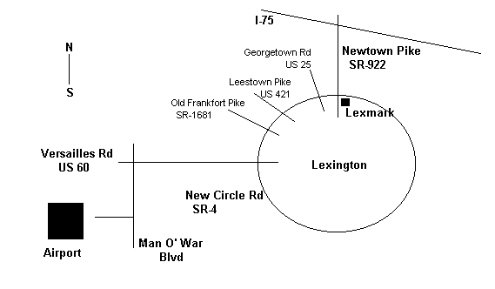

From the Cincinnati Airport, follow the route below to get to Lexington:
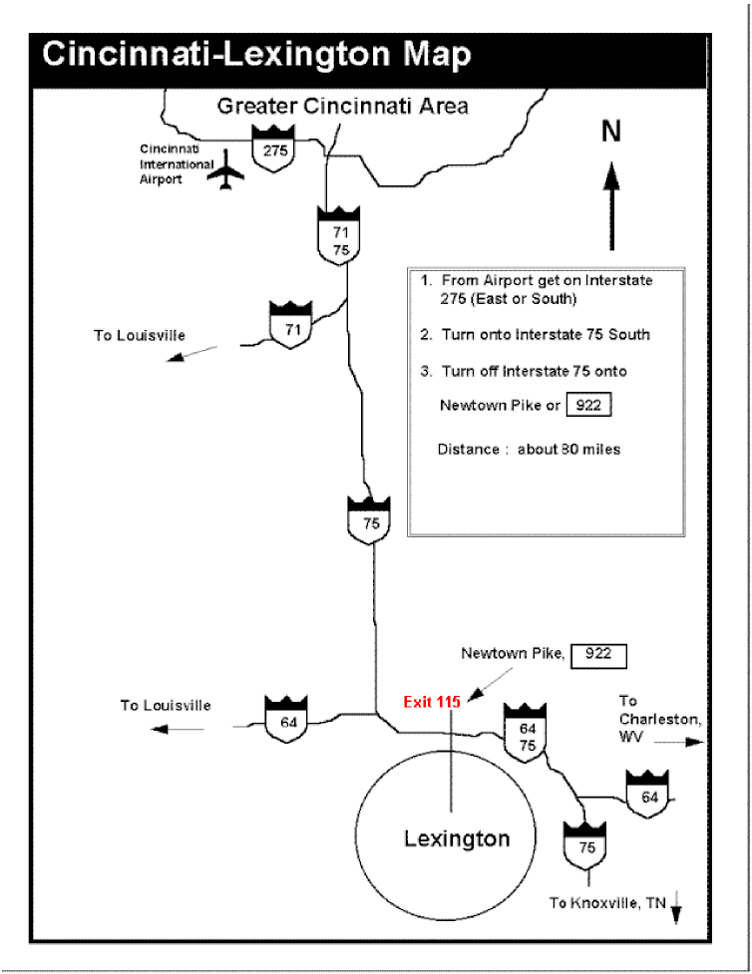

From the Louisville (SDF) airport follow the route below to Lexington.

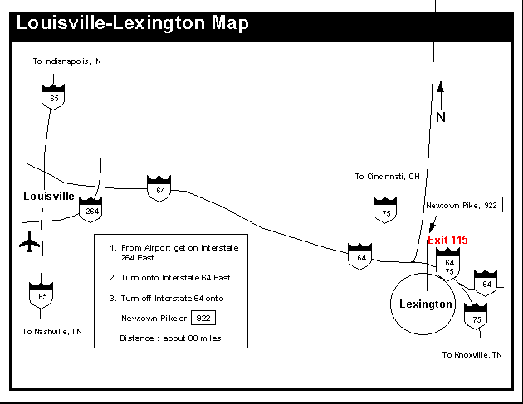

NOTE: Significant interstate construction on I64 between Lexington and Louisville.
Hotels close to the Lexmark site:
Embassy Suites
Lexmark 2010 rate = $105.00,
1801 Newtown Pike
Lexington, KY 40511
859-455-5000

Courtyard Lexington North (by Marriott)
Lexmark 2010 rate = $83.00
775 Newtown Court
Lexington, KY 40511
859-253-4646

Griffin Gate Marriott
Lexmark 2010 rate = $105.00
1800 Newtown Pike
Lexington, KY 40511
859-231-5100

Holiday Inn North
Lexmark 2010 rate = $74.00
1950 Newtown Pike
Lexington, KY 40511
859-233-0512

Hotels in downtown Lexington:

Hilton Lexington Downtown
Lexmark 2010 rate = $98.00
369 W. Vine Street
Lexington, KY 40507
859-231-9000

Hyatt
Lexmark 2010 rate = $99.00
401 W. High Street
Lexington, KY 40507
859-253-1234

Taxi service and Public Transportation in Lexington are marginal at best…some hotels provide bus service to/from the airport and to/from the Lexmark site, however a rental car is probably the best option.

Other various links that may be helpful if you are looking for local events.

http://www.keenland.com/

http://www.kyhorsepark.com/

http://www.woodfordreserve.com/story3.asp

http://www.visitlex.com/

http://www.kytourism.com/

Google Map of the Lexmark location:

http://local.google.com/local?f=q&hl=en&q=740+W+New+Circle+Rd,+Lexington,+KY+40511&ie=UTF8&om=1&ll=38.053363,-84.535847&spn=0.235199,0.521164

http://local.google.com/local?f=q&hl=en&q=740+W+New+Circle+Rd,+Lexington,+KY+40511&ie=UTF8&om=1&ll=38.069481,-84.485679&spn=0.014697,0.032573&t=h

