Scan Service Use Cases

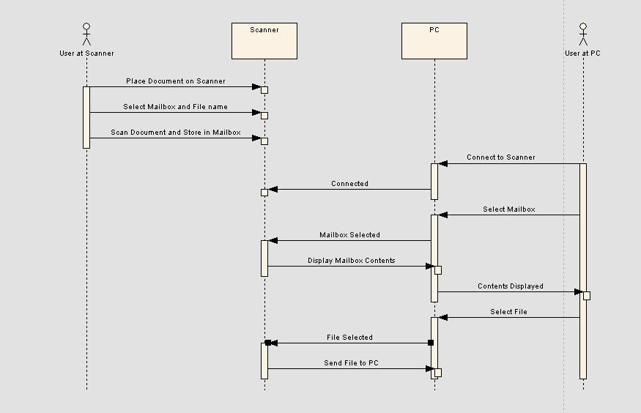
Use Case #3

