Scan Service Use Cases

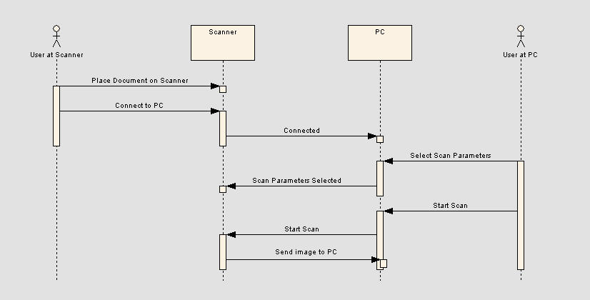
Use Case #2

