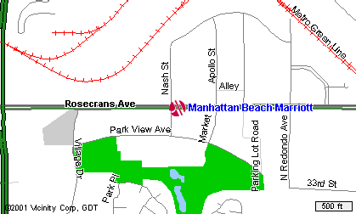
Douglas & Rosecrans Metro

