Universal Printer Description Format
Specification
Version: Draft 0.6
Section: Configuration files

Device Configuration

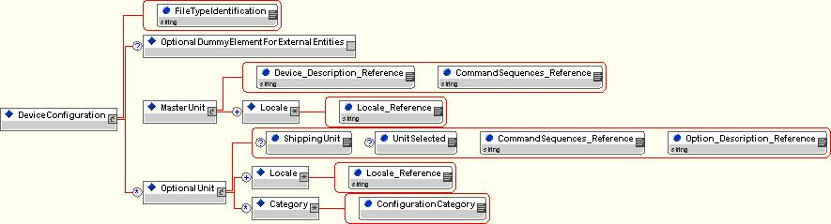

The device configuration file “UPDF Device Configuration-xxx.xml” is the UPDF entry point for a driver into the data description.

An installation process can change the device specific configuration by adding/removing or selecting/deselecting optional units.
If a device configuration is already available on a system, the installer may ask to overwrite it or work with the current configuration as input parameters.
The original device configuration will never be changed.

An installer and/or driver may verify it works with the correct file by checking the FileTypeIdentification attribute. It is “Device configuration”.
An installer may copy this file to the host or copy its content to a registry or similar system file.

The only reason for OptionalDummyElementForExternalEntities for being mentioned is to allow the use of external entities from “UPDF Entities.dtd”.

The device configuration has exactly one reference to the UPDF description of the device listed in the Device_Description_Reference attribute.
The device configuration has exactly one reference to the UPDF description of the command sequences listed in the CommandSequence_Reference attribute.
The device configuration has an arbitrary number of references to UPDF descriptions of locales listed in the Locale_Reference attribute of each locale.

The device configuration has an arbitrary number of references to optional units.
Each optional unit has exactly one reference to the UPDF description of the optional unit listed in the Option_Description_Reference attribute.
Each optional unit has exactly one reference to the UPDF description of the command sequences listed in the CommandSequence_Reference attribute.
Each optional unit has an arbitrary number of references to UPDF descriptions of locales listed in the Locale_Reference attribute of each locale.
Each optional unit has a shipping (ShippingUnit) and a selection (UnitSelected) flag attribute to indicate whether a unit is shipped with the device and whether it is currently selected.
The shipping flag is to be treated as read-only.
Both flags are supposed to be set TRUE for shipping units.
The selection flag may be changed by the installer or the driver depending on changing configurations.

The concept allows to add optional units to the original device configuration, even if they are not shipping units. In that case the two flags to not supposed to be set.

Optional Unit Configuration

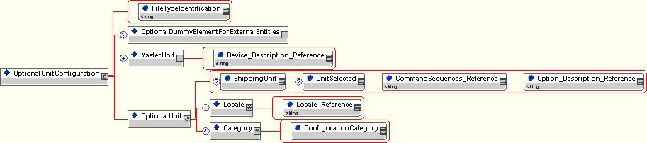

An installer and/or driver may verify it works with the correct file by checking the FileTypeIdentification attribute. It is “Option configuration”.

The only reason for OptionalDummyElementForExternalEntities for being mentioned is to allow the use of external entities from “UPDF Entities.dtd”.

The optional unit configuration has exactly one reference to the UPDF description of the optional unit listed in the Option_Description_Reference attribute.
The optional unit configuration has exactly one reference to the UPDF description of the command sequences listed in the CommandSequence_Reference attribute.
The optional unit configuration has an arbitrary number of references to UPDF descriptions of locales listed in the Locale_Reference attribute of each locale.
Each optional unit has a shipping (ShippingUnit) and a selection (UnitSelected) flag attribute to indicate whether a unit is shipped with the optional unit and whether it is currently selected.
The shipping flag is to be treated as read-only.
Both flags are supposed to be set FALSE for external units by default.
The selection flag may be changed by the installer or the driver depending on changing configurations.

The optional unit configuration has an arbitrary number of, but minimum one reference to master units, where it can be used with. This is to avoid that an optional unit description can be connected to any device driver.
Each master unit has exactly one reference to the UPDF description of the device listed in the Device_Description_Reference attribute. This is the parameter to be compared with the Device_Description_Reference attribute of the target device configuration during installation.

An optional unit configuration file is not supposed to be copied to the host.
Only the optional unit section is to be merged into the target device configuration.

Architecture
A device configuration may change during installation or re-installation and the selection flag even during the work with the driver.
UPDF description files are to be treated as read-only.
This works as a security feature for the normally complex description files and makes it very easy to add or remove optional units with touching the descriptions neither of the optional unit nor the device.

This flexibility is the reason that we have added the references to locale and command sequence descriptions to the device configuration as well.
This allows it to re-use locale and/or command sequence descriptions for different units and will drop development time rapidly after the first model of a device family is described.

